**Project Design Phase-II**

**Data Flow Diagram & User Stories**

|  |  |
| --- | --- |
| 📅 Date | 30JUNE 2025 |
| 👥 Team ID | LTVIP2025TMID31307 |
| 👥 Team Size | 4 |
| 👑 Team Leader | K Veera Venkkateshh |
| 👤 Team Members | - G Satya Veera Durga Prasad  - K Manikanta  - K Vikhitha |
| 📌 Project Name | Public Transport Management System |

**Data Flow Diagram**

Context Level DFD Description

The data flow diagram represents how data moves through the CRM Application For Public Transport Management System. Key flows include:

* **Transport Department Administrator:** Enters and manages records for Employees, Bus Stations, Buses, Routes, Ticket Fares, and Daily Bus Trips.
* **System (Salesforce):** Processes and stores all operational data, automates calculations (e.g., total fare), and generates assignments (drivers/buses to trips).
* **Transport Operations Manager:** Accesses real-time reports and dashboards for insights into passenger counts, revenue, and trip efficiency.
* **Driver/Conductor:** Views assigned trips and updates trip-specific details like passenger counts (future mobile integration).
* **Data:** All operational data is stored securely and centrally in the Salesforce database, ensuring consistency and accessibility for reporting and analysis.

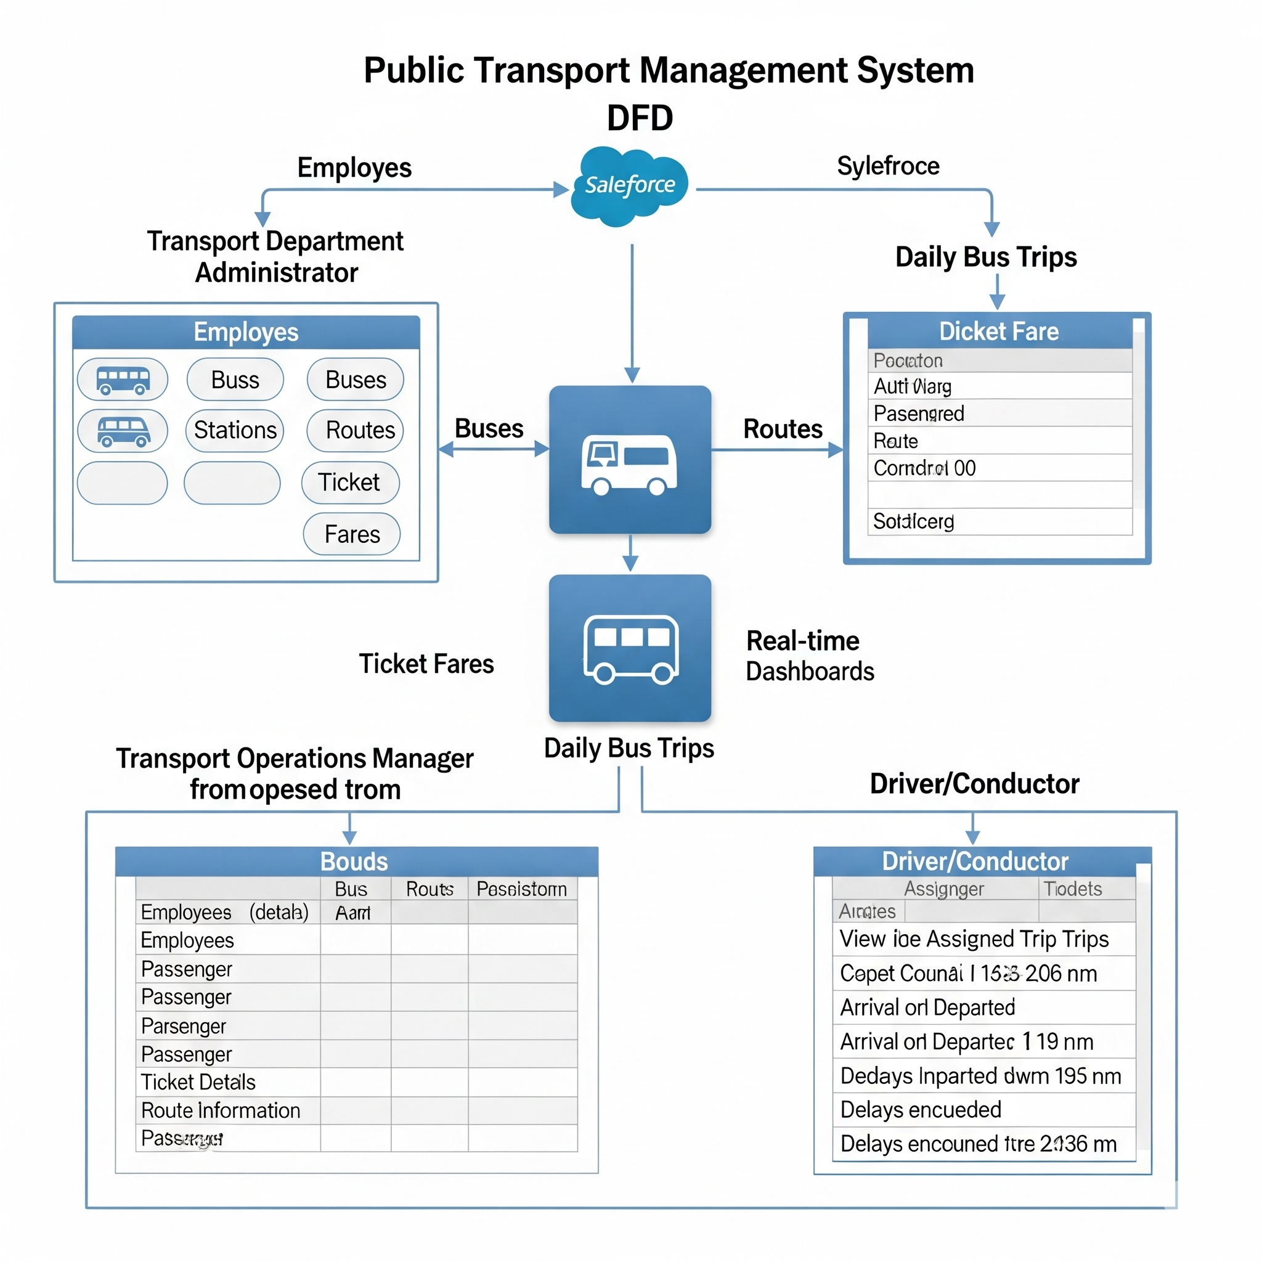

**User Stories**

| User Type | Functional Requirement (Epic) | User Story Number | User Story / Task | Acceptance Criteria | Priority | Release |
| --- | --- | --- | --- | --- | --- | --- |
| **Transport Dept. Administrator** | Employee Management | USN-1 | As a Transport Dept. Admin, I can create, edit, and view employee records in the system. | New employee records are saved and searchable; existing records can be updated correctly. | High | Sprint-1 |
| **Transport Dept. Administrator** | Bus & Station Management | USN-2 | As a Transport Dept. Admin, I can create and manage Bus records including model and capacity. | New bus records are created with correct details; bus information is easily retrievable. | High | Sprint-1 |
| **Transport Dept. Administrator** | Bus & Station Management | USN-3 | As a Transport Dept. Admin, I can create and manage Bus Station records with location details. | New bus station records are saved with location info; all station records are viewable. | High | Sprint-1 |
| **Transport Dept. Administrator** | Trip & Fare Management | USN-4 | As a Transport Dept. Admin, I can define and manage Ticket Fares for different routes and bus types. | Ticket fare rules are configured and applied correctly to routes/bus types. | High | Sprint-2 |
| **Transport Dept. Administrator** | Trip & Fare Management | USN-5 | As a Transport Dept. Admin, I can create Daily Bus Trip records and assign buses and employees to them. | Daily trips are linked to specific buses, routes, and assigned drivers/conductors; trip details are complete. | High | Sprint-2 |
| **Transport Operations Manager** | Reporting & Dashboards | USN-6 | As a Transport Operations Manager, I can view real-time reports on daily passenger counts. | Reports display accurate passenger numbers for specified dates and routes; data is refreshed promptly. | High | Sprint-4 |
| **Transport Operations Manager** | Reporting & Dashboards | USN-7 | As a Transport Operations Manager, I can view dashboards summarizing total revenue from trips. | Dashboards show aggregated revenue figures from all trips; visual components are clear and interactive. | High | Sprint-4 |
| **System** | Automation - Flows | USN-8 | As the system, I can automatically calculate the total ticket fare amount for each trip based on passenger count. | Total ticket fare field on Daily Bus Trip records is automatically updated upon passenger count entry. | High | Sprint-3 |
| **System** | Data Integrity - Validation Rules | USN-9 | As the system, I can prevent invalid data entry for critical fields (e.g., negative passenger counts). | Users receive clear error messages for invalid inputs; records cannot be saved until issues are corrected. | Medium | Sprint-3 |
| **Driver/Conductor** | Trip Management | USN-10 | As a Driver/Conductor, I can easily view my assigned daily trips and their details. | My assigned trips are accessible and display relevant information (route, bus, time) clearly. | Medium | Sprint-2 |